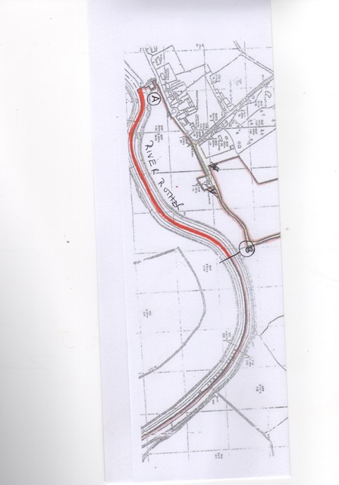

New RFA Water -

New water obtained in 2019 - Lossenham Lane, Newenden, Kent. About ½ mile along lane, gate by pump house - Point A - and extends to yellow marker post Point B - 500 metres