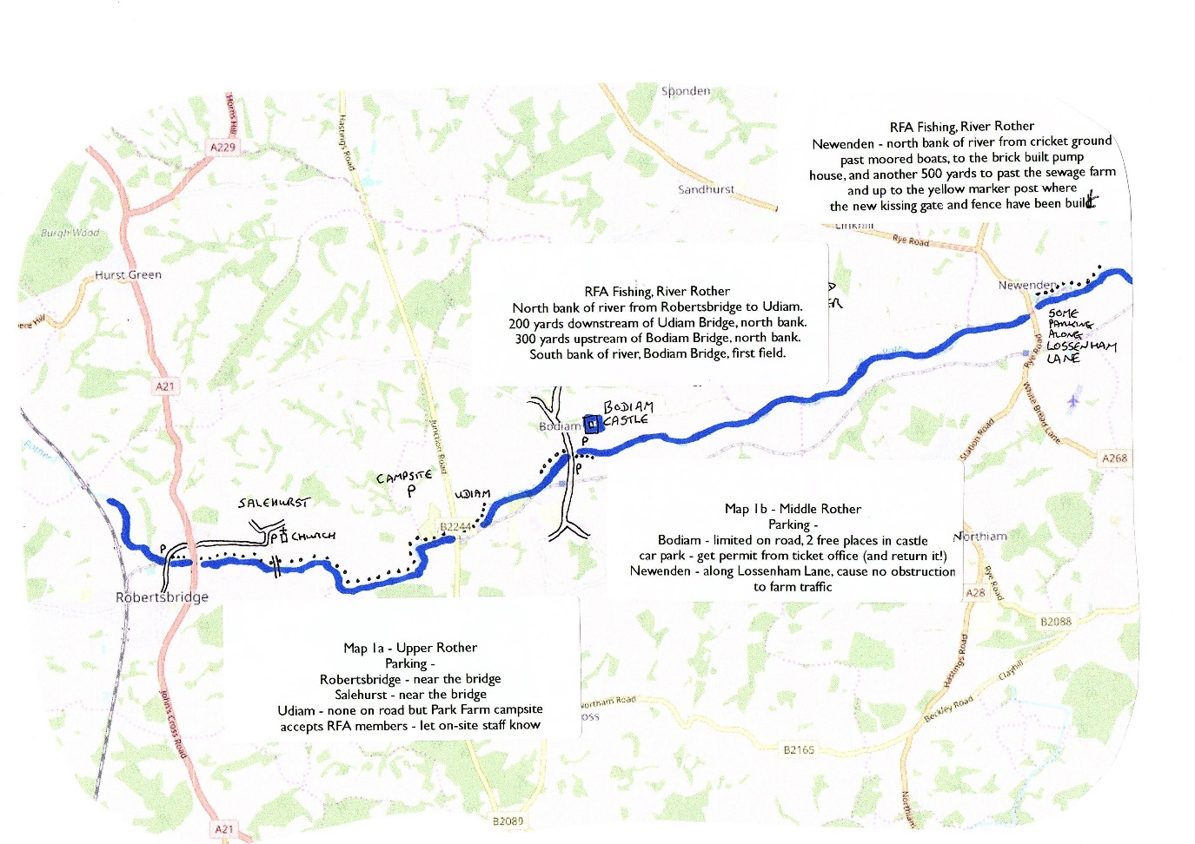

Newenden

Bodiam

A229 from

Hawkhurst

Park Farm

Campsite

(Parking)

Udiam

Salehurst

Robertsbridge

A21 from

Tonbridge