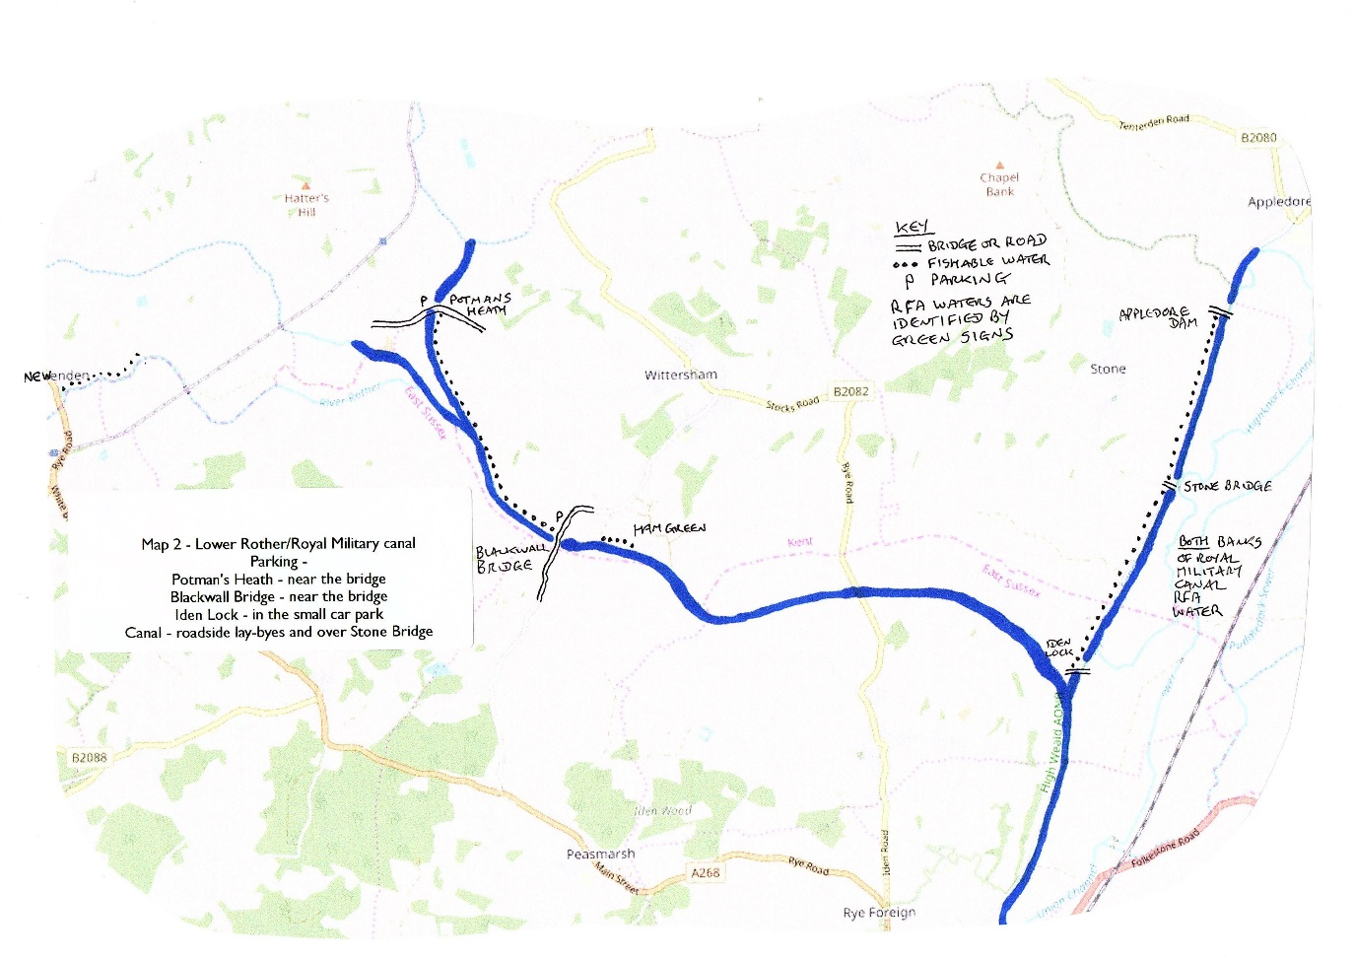

Appledore

Newenden

Both banks of

Royal Military Canal along the Royal Military Road are RFA water

Iden Lock

Rye

Peasmarsh

Ham Green

Stone Bridge

Appledore Dam

Blackwall Bridge

Wittersham

Potman’s Heath